

1)Suhel Harishchandra Bhadane

2)Mali Sujit Subhash

3)Sonavane Jayesh Popatrao

4)Patkar Avinash Murlidhar

**“Digital Analog Clock” Website”**

**A**

**Semester Project-I Report**

**On**

**“Digital Analog Clock Website”**

In partial fulfilment of requirements for the degree of

Bachelor of Technology

In

Computer Engineering

**Submitted By**

1)Suhel Harishchandra Bhadane

2)Mali Sujit Subhash

3)Sonavane Jayesh Popatrao

4)Patkar Avinash Murlidhar

**Under the Guidance of** Prof. S.R.Sonawane



**The Shirpur Education Society’s**

**R. C. Patel Institute of Technology, Shirpur - 425405.**

**Department of Computer Engineering**

**[2022-23]**



**The Shirpur Education Society’s**

**R. C. Patel Institute of Technology**

**Shirpur, Dist. Dhule (M.S.)**

**Department of Computer Engineering**  CERTIFICATE

This is to certify that the Semester Project-I entitled “**Digital Analog Clock Website”** has been carried out by team:

**1)Suhel Harishchandra Bhadane**

**2)Mali Sujit Subhash**

**3)Sonavane Jayesh Popatrao**

**4)Patkar Avinash Murlidhar**

Under the guidance of **Prof. S.R.Sonawane** in partial fulfilment of the requirement for the degree of Bachelor of Technology in Computer Engineering (Semester-III) of Dr. Babasaheb Ambedkar Technological University, Lonere during the academic year 2021-22.

**Date:**

**Place: Shirpur**

**Guide Semester Project-I Coordinator**

**Prof. S.R.Sonawane Prof. S. S. Sonawane**

**H.O.D. Director**

**Prof. Dr. Nitin N. Patil Prof. Dr. J. B. Patil**

**ACKNOWLEDGEMENT**

It is a privilege for us to have been associated with Prof. S.R.Sonawane, our guide during Semester Project 1 have been greatly benefited by his valuable suggestion and ideas. It is with great pleasure that we express our deep sense of gratitude to his valuable guidance, constant encouragement and patience throughout this work.

We express out gratitude to Prof. Dr. Nitin N. Patil (HOD of Computer Engineering) for his constant encouragement, co-operation, and support and also thankful to all people who have supported us and also thankful to all people who have contributed in their own way in making this task Success.

We would also like to extend our gratitude towards Director Prof. J. B. Patil for providing us with all the facility that was required.

**Project Team: Name**

**1)Suhel Harishchandra Bhadane(SY-A-10)**

**2)Mali Sujit Subhash(SY-A-53)**

**3)Sonavane Jayesh Popatrao(SY-A-56)**

**4)Patkar Avinash Murlidhar(SY-A-69)**

**)**

R.C.P.I.T,Shirpur

**PAGE INDEX**

**Chapter Topic Page No.**

# No.

ABSTRACT 1

###### 1. INTRODUCTION 2

1.1 IMPLEMENTATION 4

1.2 INTERFACE BEHIND 5

1.3 PERFORMANCE 6

###### 2. REQUIREMENTS

2.1 SOFTWARE REQUIREMENTS 7

2.2 HARDWARE REQUIREMENTS

###### 3. IMPLEMENTAION DETAILS

3.1 PSEUDO CODE 8

3.2 OUTPUTS 13

3.3 RESULT 17

CONCLUSION

BIBLIOGRAPHY

“Digital Analog Clock Website” (i)

#### ABSTRACT

*Title :Digital Analog Clock Website.*

*The aim of the project is to design a twelve hour Digital Analog Clock Website that displays the time in digital and Analog format. In an analog clock the time is indicated by the positions of rotating hands, whereas in a digital clock time is represented in digits.* The project aims at developing a digital and analog clock using the HTML, CSS, JavaScript, Bootstrap Technology that displays an analog and as well as a digital clock. *. The project also has other functionalities such as stopwatch and alarm clock. Stopwatch is a clock that measures exactly how long a certain task takes time. Alarm is a clock which will notify or wake us up at certain time. It will be used to reduce distraction and to focus more.*

*The Project contains below files*

* *Index.html*
* *Style.css*
* *Analog.html*
* *Style-Analog.css*
* *Analog.js*
* *Digital.html*
* *Style-Digital.css*
* *Digital.js*
* *Stopwatch.html*
* *Style-Stopwatch.css*
* *Stopwatch.js*
* *Alarm.html*
* *Style-Alarm.css*
* *Alarm.js*
* *Image.jpg*

# CHAPTER- 1 INTRODUCTION

###### 1. INTRODUCTION

The aim of our website is to show time in a digital and analog format along with other functionalities like stopwatch, alarm day & night mode. It is an website that has all the functionalities at one place. It reduces tedious task of visiting different places for some different function of a clock.. It is also very useful for academic purpose, which can help to reduce distractions rather than preferring general way of viewing time we can use this website which will allow us to do all the task at one single place. Clock is generally of two types digital and analog. The aim of the project is to design a twenty four hour Digital Analog Clock Website that displays the time digitally and analogically.`

Digital Clock shows numbers to display the time in a digital format Digital Clock is an excellent way for viewing time in the format of digits. Digital clocks come with more features than their analog counterparts. Digital

clocks provide superior readability during tense, time.

sensitive scenarios, and some digital models can help people track the time with the help of a countdown timer. They can help to get students to their next classroom on time. Medical staff can rely on the countdown timer during medical procedures. Manufacturing facilities can track tasks, activities, and efficiency by using a countdown timer, as well.. With the help of HTML, CSS Javascript a digital clock to display time in hours, minutes and seconds can be constructed.

Analog Clock shows the time with the help of positions of rotating hands. With the help of HTML, CSS Javascript a digital clock to display time in hours, minutes and seconds can be constructed. Clock which shows time with two moving hands which move in circular motion and the clock face is marked from 1 to 12.

This clock has some more functionalities like stopwatch and alarm.

We can also set the alarm and it will notify us on that particular time with a ringing bell.

In this project we have shown how a clock website is presented along with its other functions. The interface of website is also user friendly.

## 1.1 Implementation

In this project we have use the concept of Web development consisting of HTML, CSS, Javascript. Now Let’s get a brief idea what we have used in our project. We have used HTML, CSS, Javascript & Bootstrap. HTML (HyperText Markup Language) is the code that is used to structure a web page and its content. The content could be structured within a set of paragraphs, a list of bulleted points, or using images and data tables. Basically it is the basic framework of website or we can refer it as the skeleton of the website.

We also have used CSS (**Cascading Style Sheets**) is used to style and layout web pages — to alter the font, color, size, and spacing of your content, split it into multiple columns, or add animations and other decorative features. We also have used Bootstrap it is a free, open source front-end development framework for the creation of websites and web apps. Designed to enable responsive development of mobile-first websites, Bootstrap provides a collection of syntax for template designs.

For functionality of the program we have used. Javascript is used by programmers across the world to create dynamic and interactive web content like applications and browsers.

Let us try to understand the project first,

In the beginning we have design navbar which will contain the name of the website, home and other functions link to it. One can go to any page by clicking them. If user click on any button it will head to that respective page and if user click on home button it will head to home page. In the navbar we have added display, analog, stopwatch, alarm buttons.When user click any button, user will get directed that page. In alarm page, user can set the alarm and the alarm will notify him with a ringing bell. In the analog section full-screen analog display of a clock which shows time opens.There will be a stopwatch button on clicking it the page will display the stopwatch which has start stop and reset option. The home page will also have a footer division where user can contact with us via Instagram or email, it also has other hyperlinks. Every page has a home button after clicking which we can go to the home page.

## 1.2 Interface Behind

How this all will work ?

First of all we will need to require all the required files for the internet. We have to install Atom or VS code IDE for running the code and. We should have command over frontend web development. Make a file index.html add a navigation bar using bootstrap after that make the front page. At the bottom build footer div with hyperlinks in it. Now make another file style.css give background color position box-model and all the things for styling the front page. After that make another file analog.html add a home button to that page and make div for clock and its hands. Now make style-analog.css style the clock and its hands in that file. Make another file analog.js inside it give functionality to the clock using Javascript. Now call and reference that style-analog.css and analog.js file into analog.html and reference that analog.html to head of index.html. This structure is the basic fundamental what we need to do in this website after that do the same for digital.html stopwatch.html alarm.html and reference them into the index.html page. By this when we click on any button on our front page it directs us towards the respective webpage and the respective webpage works as it has its own functionality. Each webpage has a home button via which it redirects user to their front page. In the alarm clock we can set snooze or stop the alarm whereas in the stopwatch we have a digital clock stopwatch which has start stop and reset button. After clicking on the digital button we can see display of digital clock which has two modes in it day-mode and night-mode. This is how the website works within the internet.

## 1.3 Performance

Our main file will be index.html in which we will have the front page which is our front page and after clicking on any button we will be able to go to its webpage where we can do the tasks such as starting a stopwatch or if user clicks on alarm he will see the alarm page interface where user will be able to set the alarm if user click on analog he will be directed towards a fullscreen analog clock with hour minute and second hands. If user clicks on digital he will be directed to the digital clock with digits. User can further use its two modes light-mode and night-mode. Every web page has a home button which will direct us to the home page of website. By using bootstrap the website is responsive which means that we can use the website in phone as well as laptop items of navbar gets into toggle button and many more function which makes the website responsive.

**CHAPTER-2 REQIUREMENTS**

## 2.1 SOFTWARE REQUIREMENTS

* Chrome
* Microsoft Edge
* Atom
* Visual studio Code

## 2.2 HARDWARE REQUIREMENTS

* Laptop
* Pen Drive

**CHAPTER-3 IMPLEMENTATION DETAILS**

###### 3.1 CODE

###### 

* **Index.html**

<!DOCTYPE html>

<html>

<head>

<meta charset="utf-8">

<title>Timzo</title>

<link rel="stylesheet" href="analog.html">

<link rel="stylesheet" href="digital.html">

<link rel="stylesheet" href="alarm.html">

<link rel="stylesheet" href="stopwatch.html">

<link rel="preconnect" href="https://fonts.googleapis.com">

<link rel="preconnect" href="https://fonts.gstatic.com" crossorigin>

<link href="https://fonts.googleapis.com/css2?family=Montserrat:wght@700&family=Ubuntu&display=swap" rel="stylesheet">

<link href="https://cdn.jsdelivr.net/npm/bootstrap@5.1.3/dist/css/bootstrap.min.css" rel="stylesheet" integrity="sha384-1BmE4kWBq78iYhFldvKuhfTAU6auU8tT94WrHftjDbrCEXSU1oBoqyl2QvZ6jIW3" crossorigin="anonymous">

<script src="https://cdn.jsdelivr.net/npm/bootstrap@5.1.3/dist/js/bootstrap.bundle.min.js" integrity="sha384-ka7Sk0Gln4gmtz2MlQnikT1wXgYsOg+OMhuP+IlRH9sENBO0LRn5q+8nbTov4+1p" crossorigin="anonymous"></script>

<link rel="stylesheet" href="css/styles.css">

<script src="https://kit.fontawesome.com/2bc98236fa.js" crossorigin="anonymous"></script>

</head>

<body>

<section id="title">

<!-- Nav Bar -->

<div class="container-fluid">

<nav class="navbar navbar-expand-lg navbar-dark">

<a class="navbar-brand" href="#">timzo</a>

<button class="navbar-toggler" type="button" data-bs-toggle="collapse" data-bs-target="#navbarSupportedContent" aria-controls="navbarSupportedContent" aria-expanded="false" aria-label="Toggle navigation">

<span class="navbar-toggler-icon"></span>

</button>

<div class="collapse navbar-collapse" id="navbarSupportedContent">

<ul class="navbar-nav ms-auto mb-2 mb-lg-0">

<li class="nav-item">

<a class="nav-link" href="index.html">Home</a>

</li>

<li class="nav-item">

<a class="nav-link" href="digital.html">Digital</a>

</li>

<li class="nav-item">

<a class="nav-link" href="analog.html">Analog</a>

</li>

<li class="nav-item">

<a class="nav-link" href="stopwatch.html">Stopwatch</a>

</li>

<li class="nav-item">

<a class="nav-link" href="alarm.html">Alarm</a>

</li>

</ul>

</div>

</nav>

<!-- Title -->

<div class="row">

<div class="col-lg-6">

<h1><b>Time waits for none.</b></h1>

<a href="analog.html" class="btn btn-dark btn-lg download-button"><i class="fa-solid fa-clock"></i>Analog</a>

<a href="digital.html" class="btn btn-outline-light btn-lg download-button"><i class="fa-solid fa-display"></i>Digital</a>

</div>

<div class="col-lg-6">

<img class="sand-time" src="images\sand-time.jpeg" alt="sand-time">

</div>

</div>

</section>

</div>

<!-- Features -->

<section id="features">

<div class="row">

<div class="feature-box col-lg-4">

<i class="fa-solid fa-clock fa-4x icon"></i>

<!-- <h3>Analog</h3> -->

<p class="feature-p">Clock which shows time with moving hands.</p>

<a href="analog.html" class="btn btn-dark btn-lg download-button">Analog</a>

</div>

<div class="feature-box col-lg-4">

<i class="fa-solid fa-display fa-4x icon"></i>

<p class="feature-p">Clock that displays time in numerical digits.</p>

<a href="digital.html" class="btn btn-dark btn-lg download-button">Digital</a>

</div>

<div class="feature-box col-lg-4">

<i class="fa-solid fa-stopwatch fa-4x icon"></i>

<p class="feature-p">Clock that measures exactly how long something takes.</p>

<a href="stopwatch.html" class="btn btn-dark btn-lg download-button">Stopwatch</a>

</div>

<center>

<div class="feature-box col-lg-4">

<i class="fa-solid fa-star fa-4x icon"></i>

<p class="feature-p">Clock to notify or wake you up.</p>

<a href="alarm.html" class="btn btn-dark btn-lg download-button">Alarm</a>

</center>

</div>

</div>

</section>

<!-- Call to Action -->

<!-- Footer -->

<footer class="bottom-container">

<a class="footer-link" href="https://instagram.com/suhel_bhadane24?igshid=ZmRlMzRkMDU=">Instagram</a>

<a class="footer-link" href="mailto:suhelbhadane@gmail.com">Contact</a>

<a class="footer-link" href="https://www.rcpit.ac.in/">RCPIT</a>

<p class="copyright">© timzo</p>

</footer>

</body>

</html>

##### 3.2 OUTPUTS

Homepage :

##### 

Homepage for website

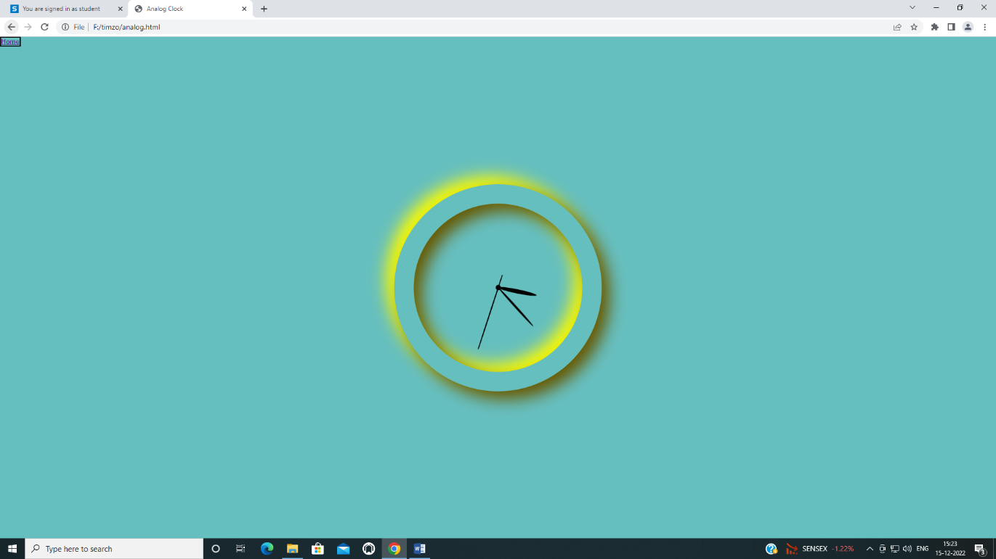Analog Clock:

It is analog clock,which show time in 12 hr format.

Digital Clock:

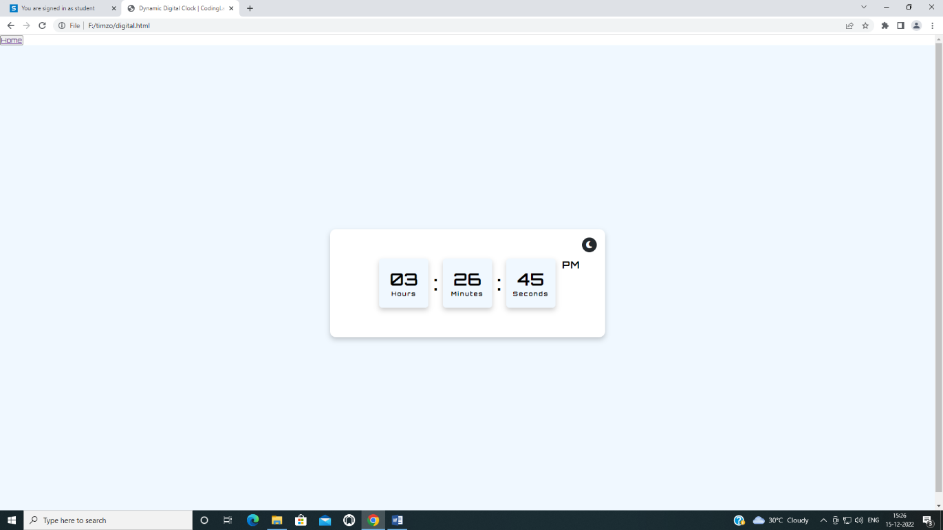

It is digital clock,show time in hours,minutes,seconds format.

Digital Clock(Dark Mode):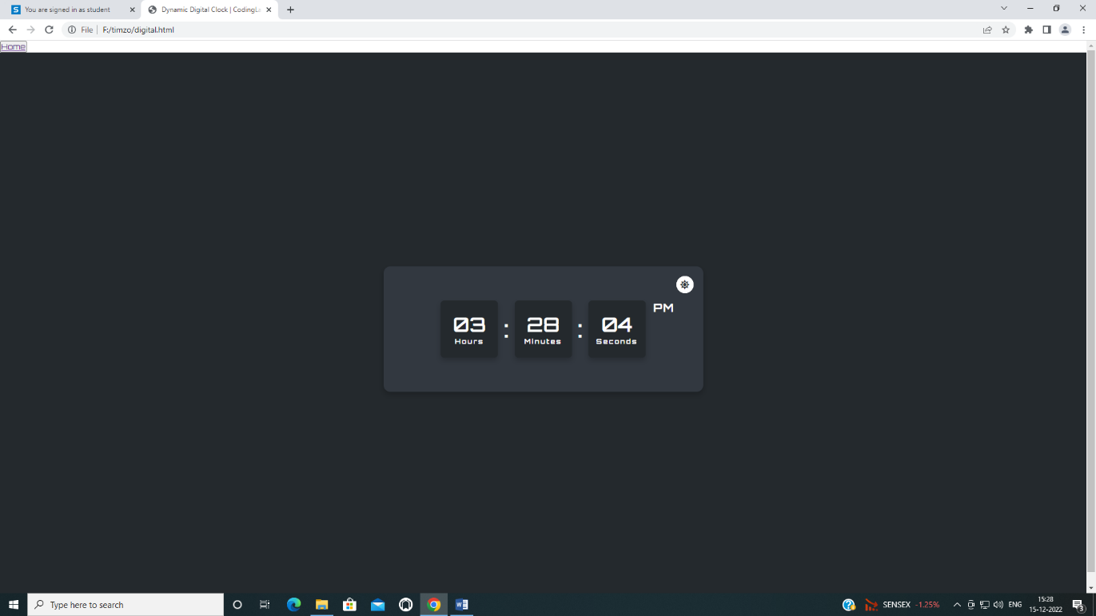

##### In dark mode

Stop Watch:

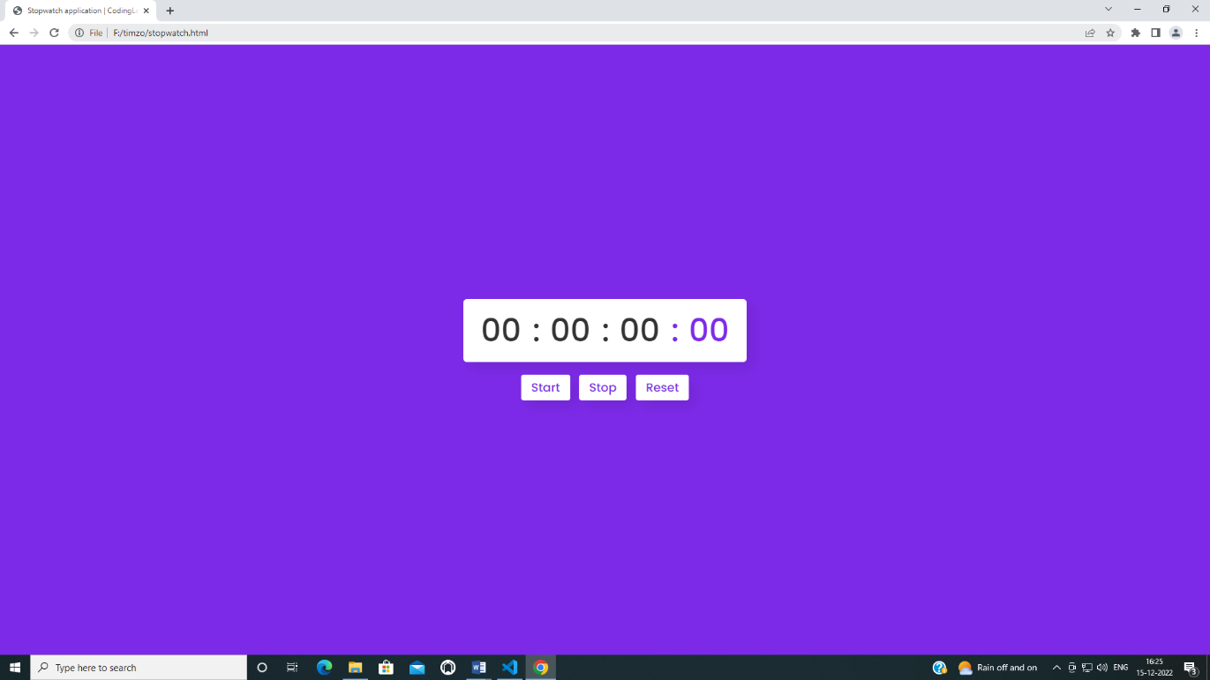

In stop watch ,we can set, reset our time,as well as stop timer

Alarm Clock:

##### 

We can set alarm with specifieng date and time.

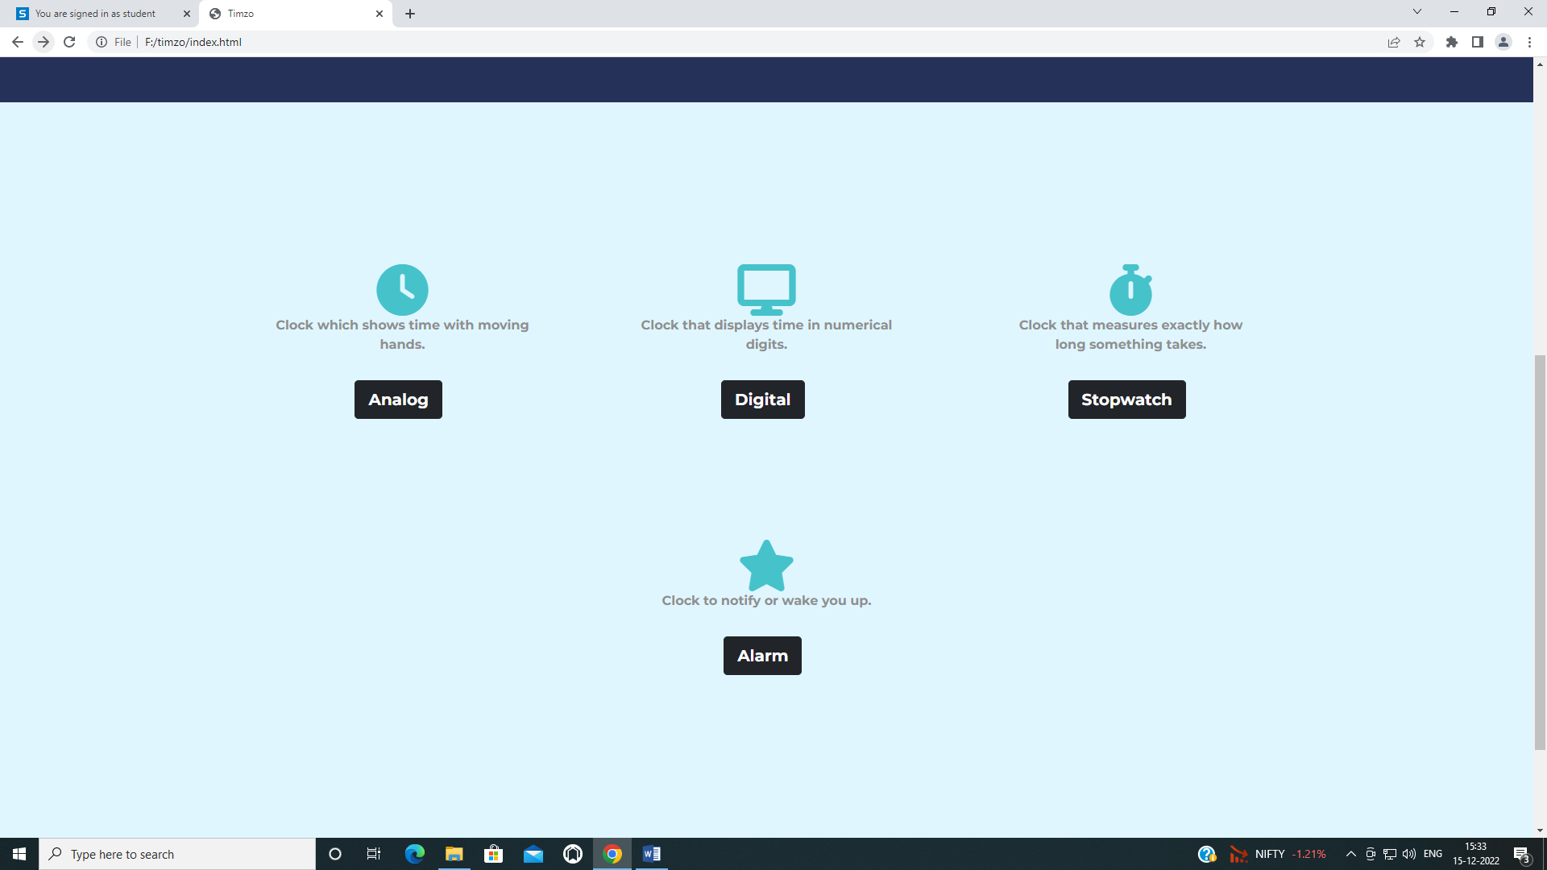

We can select anyone option from above Analog clock,Digital clock,Stopwatch,Alarm.

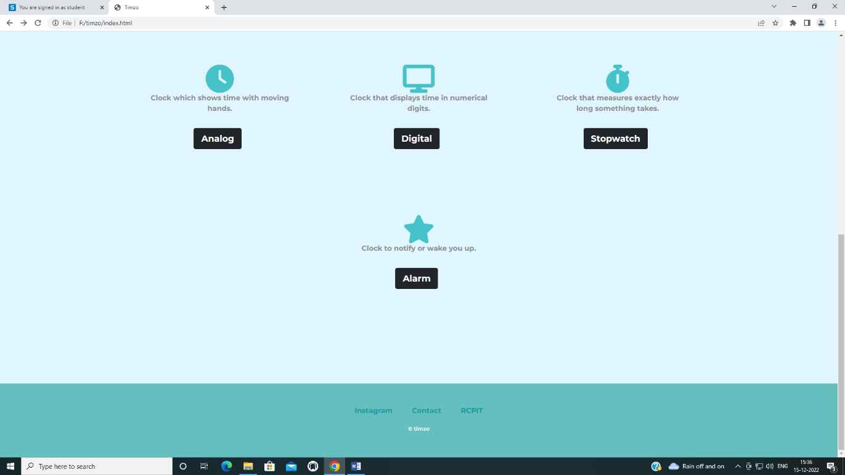

Contact details are provided here.

##### 

##### 

##### 3.3 RESULT

Digital Clock Website is really good website for using multiple functions of clock at one place. Viewing time in different type of clocks using stopwatch and setting alarm can be easy on this website and it is responsive as well. Also this website will help when we use ultra power saving mode at that time only chrome and some selected apps can be used at that time we can use this website to set alarm or use stopwatch. User interface is also user friendly which makes user to easily understand the features of the website.

### CONCLUSION

* We can conclude that the website is working well. It is error free as well.
* The website can be used for multiple purpose.
* Anyone can access this website from anywhere in the world

###### BIBLIORGAPHY

1. Douglas Crockford*, “JavaScript: The world's most misunderstood programming language”*, *2001.*
2. “MDN Docs”, *Introducing the CSS Cascade - CSS: Cascading Style Sheets | MDN (mozilla.org)*
3. Douglas Crockford*, “JavaScript: The world's most misunderstood programming language”*, *2001.*
4. “Google fonts”, https://fonts.google.com
5. “Bootstrap”, https://getbootstrap.com
6. [978-1-4493-3558-8], Kylie Simpson, “*You Don’t Know JS: Scope & Closures*”, March 2014
7. “Font awesome”,https://fontawesome.com/
8. “Code pen”,https://codepen.io/
9. “Github”https://github.com
10. “w3 school”https://www.w3schools.com